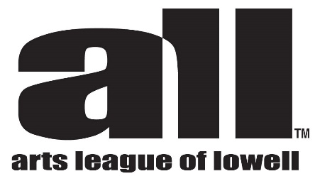
Call for Artists
Here We Are/Faces of Creativity
An exhibit of artists’ self portraits
As part of our mission to encourage and support local artists, ALL is planning a show in February 2023 to make visible the large and multitalented cohort of artists who live and work in Lowell. Please plan to participate, and encourage your friends as well. The show is open to all artists and there is no fee.
This is a call for artists from all areas of Lowell, membership in arts associations is not a requirement and there is no fee. Work must be original and conform to the size specified. All media will be considered.
THE RULES:
You must be a Lowell resident or a member of any of the artist communities.
Must be past High School age (College and University students are welcome)
All work must measure 8” square
Work must be flat, either on 8” x 8” canvas board, or similarly sized heavy paper or board
No works on stretched canvas
No works with additional framing, matting, glass etc.
All media accepted, including photography, collage, printmaking, drawing etc.
Digital work must be entirely from your hand with no AI programs used
Work may be NFS or priced for sale (40% commission to gallery)
You may pick up a free canvas board (one per artist) at the gallery beginning Oct. 26
3D work will be considered but must fit the 8x8x8’’ format
Exhibit Dates:
February 1 through 26, ALL Arts Gallery, 307 Market St. Lowell
Deliver labelled work to the gallery by January 20

Questions: contact Mary Hart mjhart206@gmail.com

